RESULTS

1. ***Accuracy***

By implementing JAGS with **five features** 1) texture mean, 2) area worst, 3) smoothness worst, 4) area mean, and 5) concavity_mean, the model has an accuracy of 97.66%. Three false positives were identified and 1 false negative was identified.

By implementing JAGS with **four features** 1) texture mean, 2) area worst, 3) smoothness worst, and 5) concavity_mean, the model has an accuracy of 98.25%. Three false positives were identified and 0 false negatives were identified.

|  |  |  |  |
| --- | --- | --- | --- |
| **Model** | **Accuracy** | **FP** | **FN** |
| 5 features | 97.66% | 3 | 1 |
| 4 features (without mean_area) | 98.25% | 3 | 0 |

1. ***Diagnostics visualizations***

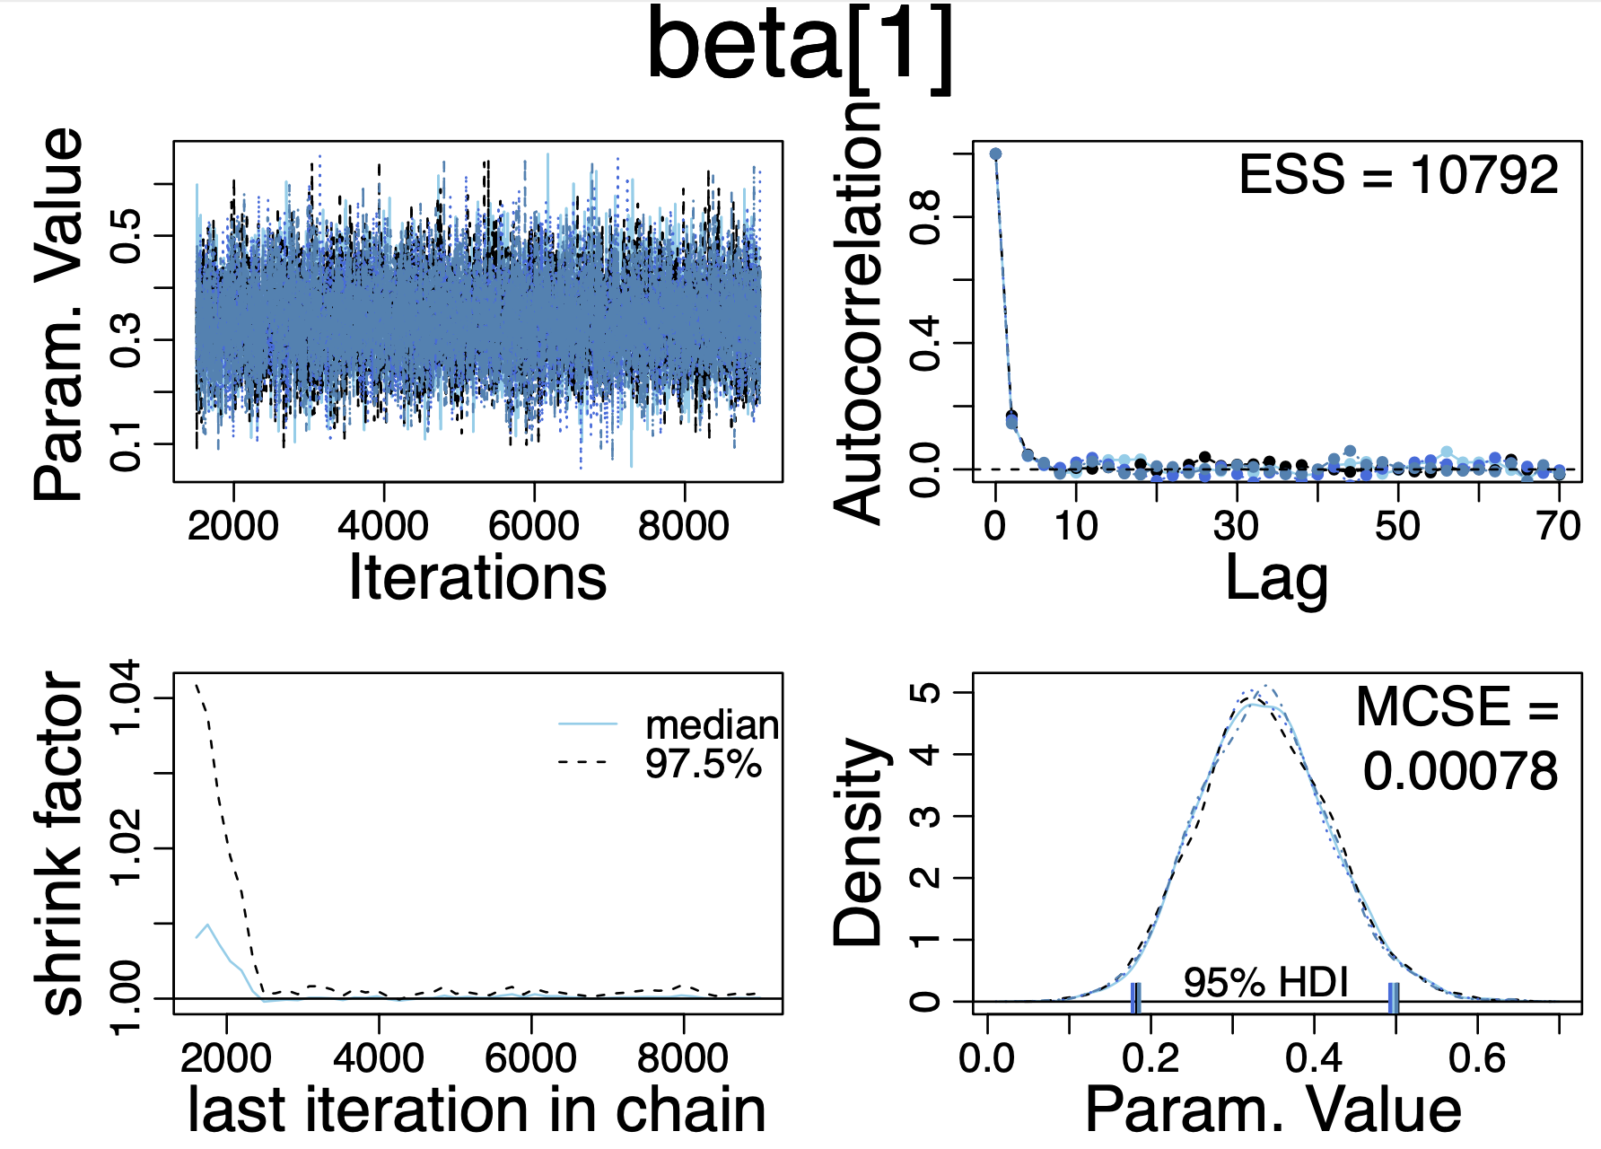 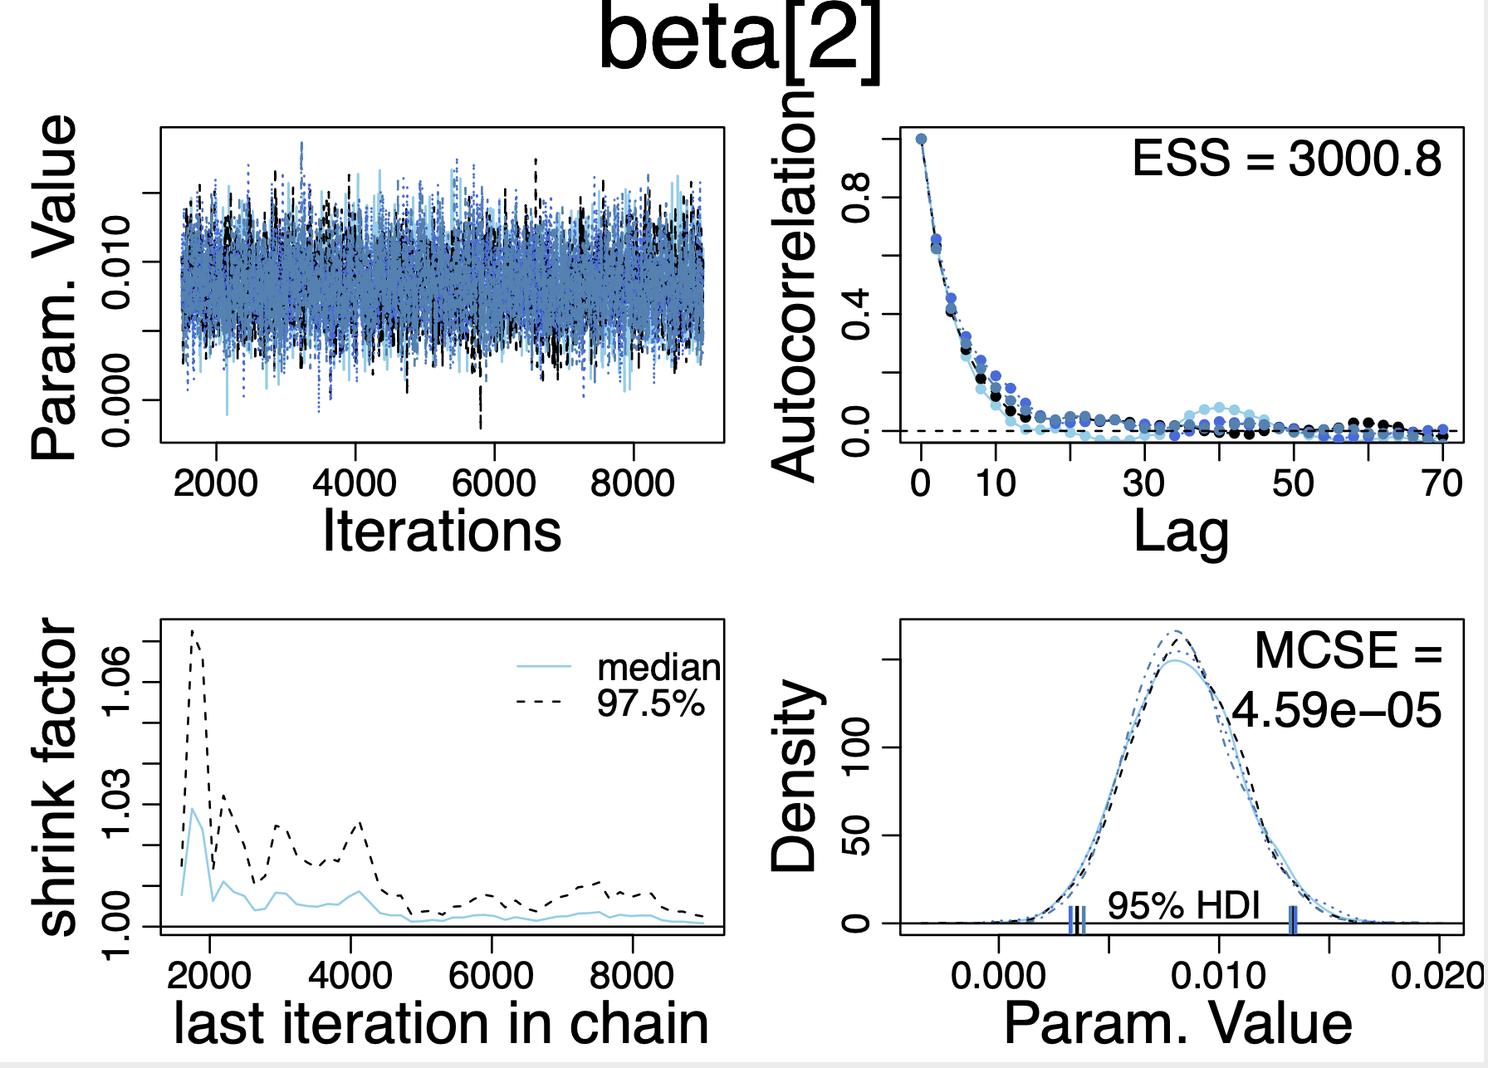

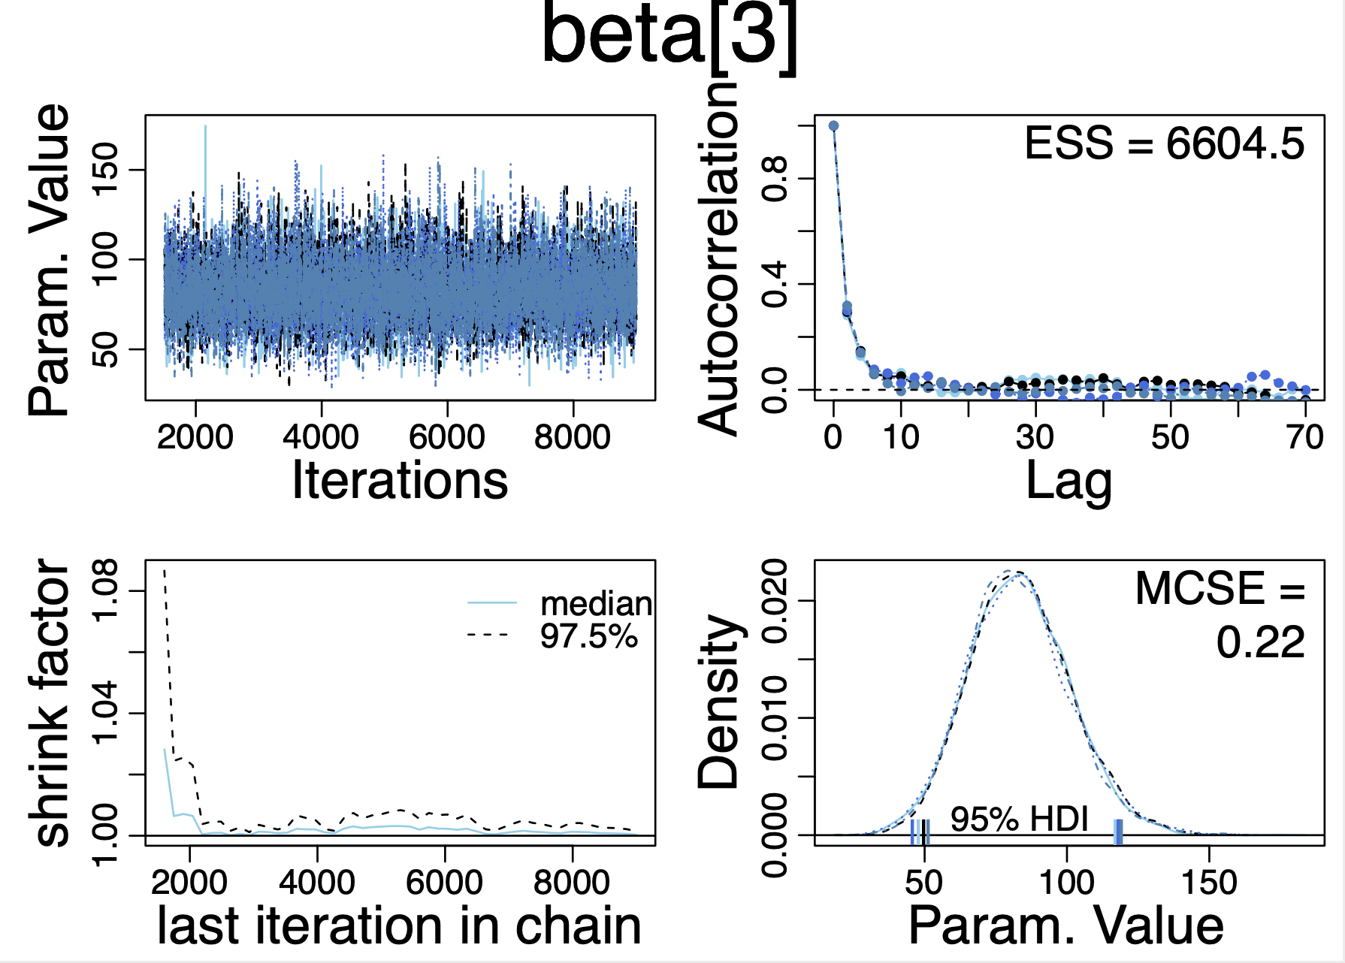 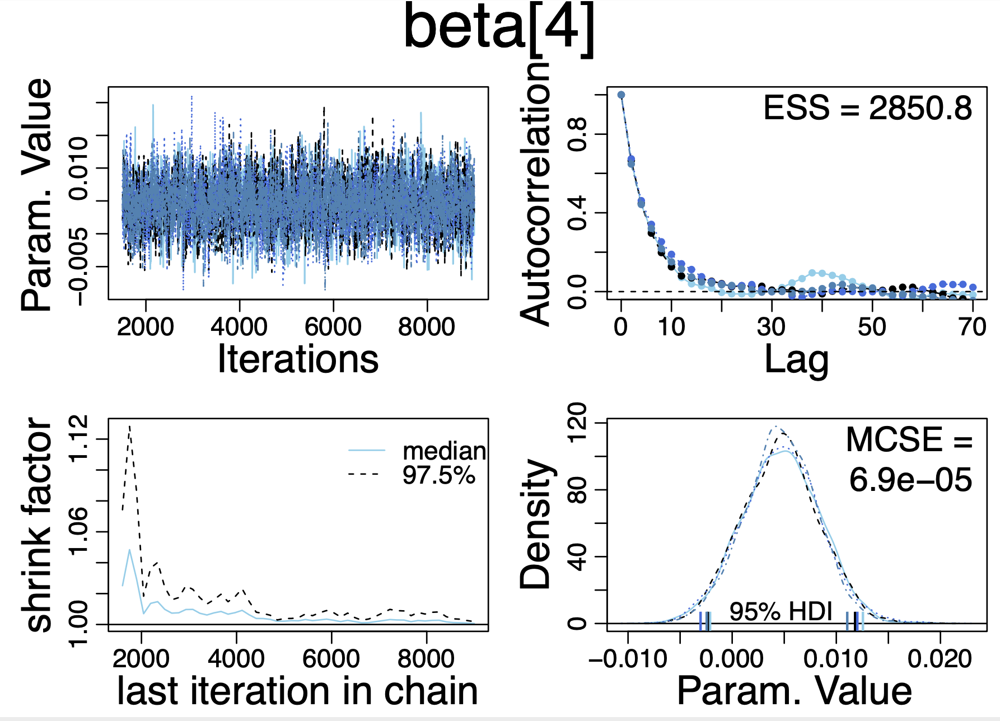

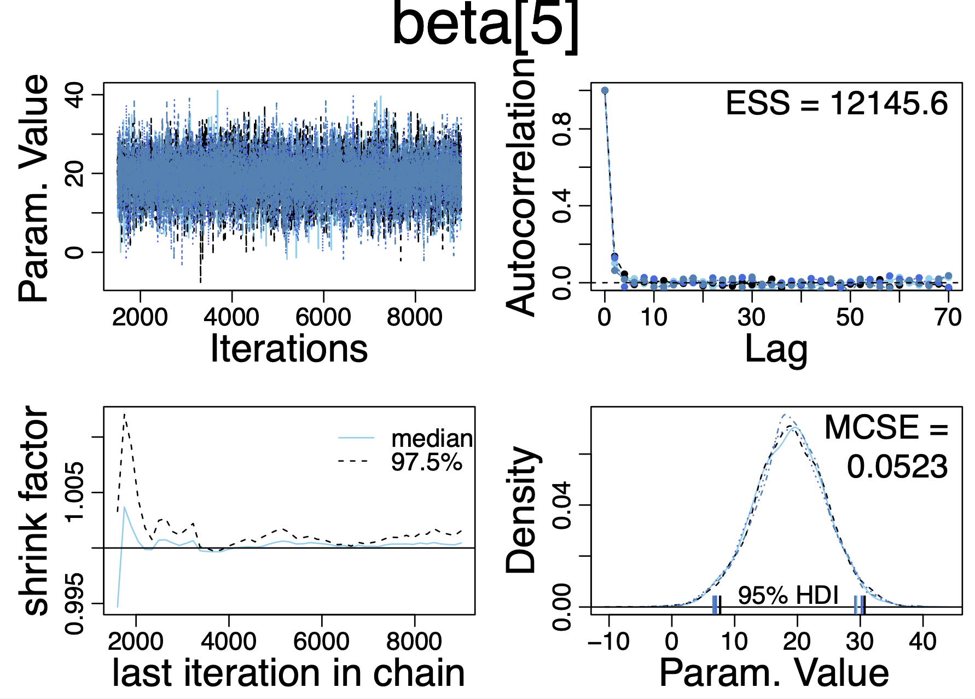

1. ***Interpretation of diagnostics***

*Visual checks of chain trajectory:*

* **Trace plots** in upper-left panels show no signs of orphaned chains. This indicates that convergence was achieved. If the chains are representative, then they should overlap and mix well.
* **Density plots** in the lower-right show smoothed histograms of the parameter values sampled in each chain. Smoothed. density plots average across overlapping intervals to produce a smooth representation of probability density. The density plots of the 3 chains are well super-imposed after the burn-in period. This suggests, but does not guarantee, that the chains are producing representative values from the posterior distribution.

*Numerical checks:*

* **Gelman-Rubin statistic** in the lower-left panel being very close to 1.0. This measure indicates how much variance there is between chains relative to how much variance there is within chains. In a good model, the variance should be close to 1.

*Conclusion*: **The information suggests that the chains are genuinely representative samples from the posterior distribution.**

Reference: Kruschke, J. K. (2011). Doing Bayesian Data Analysis. A Tutorial with R, JAGS, and STAN. 2nd edition. pp. 178-187.